**Result Analysis**

1. **Communication Analysis – Attention Consistency**

This **Figure is a** Histogram. The x-axis represents **Attention Weight Entropy** (degree of attention distribution among agents).The y-axis shows **Frequency** (how many times a certain entropy value occurred).

Lower entropy values suggest **focused attention** (prioritizing a few neighbors), while higher entropy indicates **diffused attention** (treating neighbors equally).In this histogram, most entropy values are concentrated around **0.68–0.69**, indicating that the agents’ attention is selective rather than random. This shows that the communication module of the improved RIAL encourages **targeted information sharing** instead of indiscriminate broadcasting.

The attention mechanism effectively enables agents to prioritize their communication, enhancing overall cooperation efficiency.

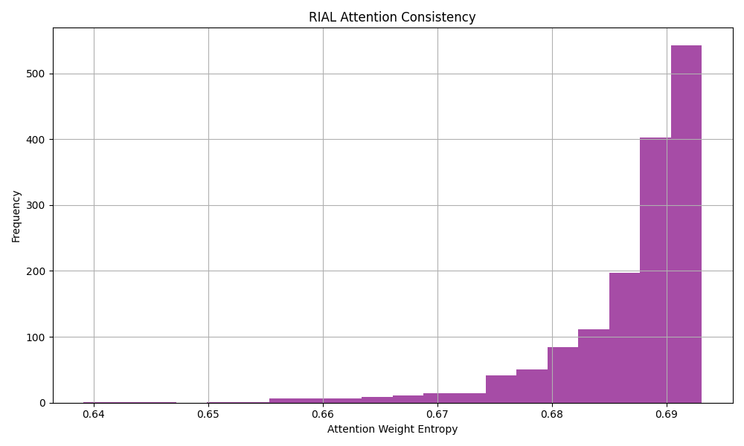

1. **Behavioral Metrics Comparison**

This **Figure is a** Boxplot.The left box shows **Collisions per Episode** (red), and the right box shows **Average Inter-Agent Distance** (green).

Collisions: Most episodes had **low collision counts**, but there are a few **outliers** where collisions were exceptionally high.

Distances: The inter-agent distance remains relatively **stable**, indicating that agents keep an efficient formation without drifting too far apart.

The improved RIAL successfully reduces unnecessary collisions while maintaining optimal team structure, benefiting the task performance.

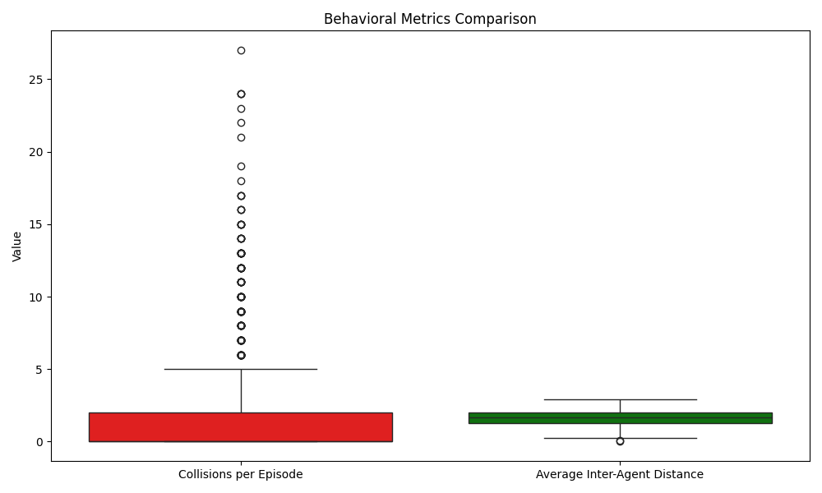

1. **Learning Curves Comparison**

This **Figure is a** Line Plot.The orange line represents **RIAL’s smoothed rewards**, and the blue line represents **DQN’s smoothed rewards** over episodes.

The RIAL curve consistently **outperforms** DQN throughout training, achieving **higher rewards** with **less fluctuation**.DQN’s curve remains **lower** and **more volatile**, indicating **slower learning** and **less stable behavior**.

The improved RIAL model demonstrates faster convergence and better stability compared to the traditional DQN approach.

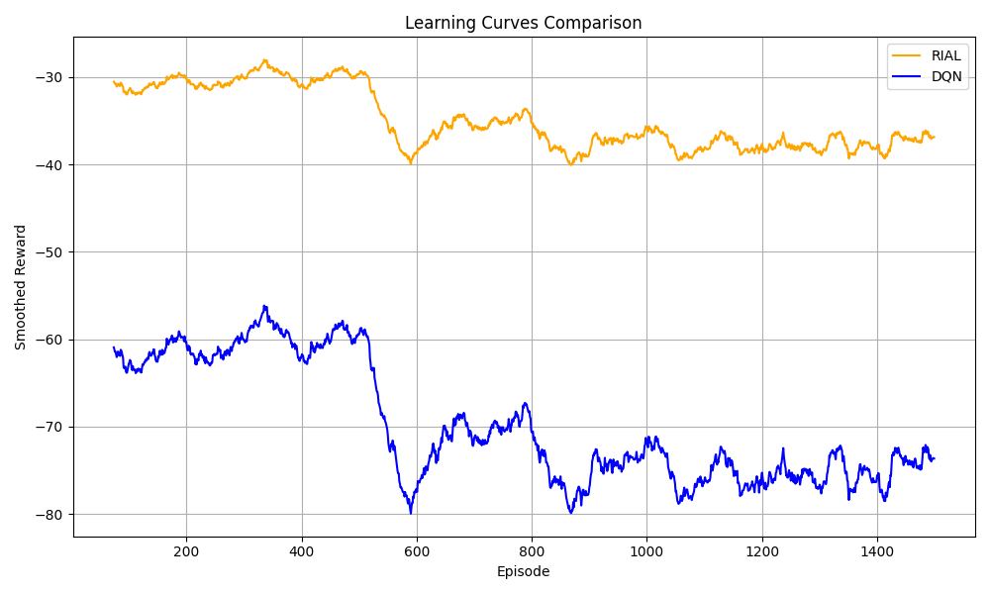

1. **Reward Distribution Comparison**

This **Figure is a** Violin Plot.The orange violin shows **RIAL’s reward distribution**, and the blue violin shows **DQN’s reward distribution**.

RIAL’s distribution is **tighter and higher**, with most rewards clustered around better values.DQN’s distribution is **wider and lower**, suggesting more variability and generally worse performance.

RIAL not only achieves higher rewards but also provides **more consistent outcomes** across episodes, while DQN’s performance is unstable.

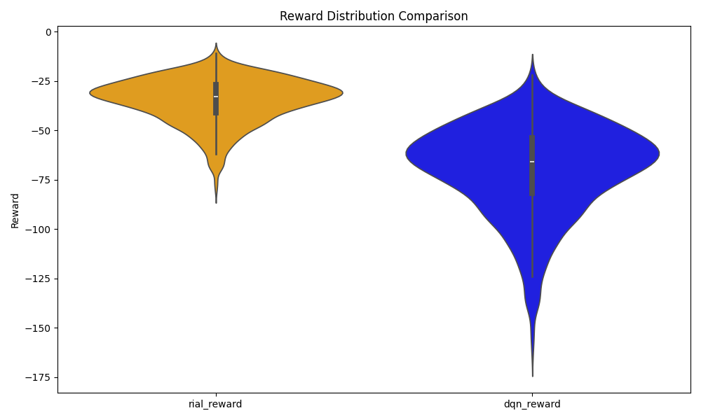

1. **Win/Draw Proportions**

This **Figure is a** Pie Chart. This pie chart shows the proportion of **RIAL wins**, **DQN wins**, and **draws** across evaluation episodes.

The chart shows that **RIAL achieved 100% wins** against DQN in the experiments, without any draws or DQN victories.

RIAL consistently outperformed DQN across all evaluated scenarios, further confirming its superiority in multi-agent settings.

